Role - Solution Architect

The solution architect is responsible for the technical direction of the project, making decisions about the strategy to be used to fulfill the requirements, both functional (business functionality) and nonfunctional requirements (speed, failover, etc.) Implementation technologies, platforms and tools and coordinating this with the developers and testers.

Revision History

|  |  |  |
| --- | --- | --- |
| **Week Number** | **Author** | **Description of changes** |
| 2 | Victoria Mannina, David Chan | Chose Database (Parse.com), Server (Parse.com), Language (Java), Platform (Andriod App) |
|  |  |  |
|  |  |  |
|  |  |  |

*Comments:*

* *This page should be updated each week and the TAs will use it to determine the week’s work done by the team-member in the particular role.*
* *For each of the items mentioned in the following pages. Be as brief as possible in your responses. A good rule of thumb is to keep each response within two paragraphs.*
* *This document represents your log of decisions. You are not bound to follow a decision blindly. You may change the decision if new aspects come to light which make your decision inappropriate. However, this may include repercussions like code rewrite etc. So choose wisely.*

*- You may delete the commented regions for your weekly turn-in submissions.*

1. Architectural Decisions

## Options

What are the technology options available that you considered? List them here.

## Decision

You have to go with one of the options. Describe the details of that option here.

## Rationale

Why did you make this choice? Describe the detailed rationale, the reasons for making the choice at this time in your project. You may need to change this decision later, but note that the change will have repercussions such as code rewrite etc.

|  |  |
| --- | --- |
| Architectural Decision Number | 1. Chose Database |
| Options | Parse.com, Mysql |
| Selected Option | Parse.com |
| Rationale | We found this and decided it fit what we needed perfectly. It had all the capabilities and is free for a limited amount of requests per second. We didn’t feel there was a need to keep searching because we didn’t need anything else as far as capabilities and it couldn’t be any cheaper. |
| Architect | Victoria Mannina and David Chan |
| Reviewed and Signed off with the following people at this date/time | Austin Han, Matthew Nguyen, Jason Dizon, John Chan, Mike Griffin, Michael Tran, Chesong Lee |

|  |  |
| --- | --- |
| Architectural Decision Number | 1. Chose Server |
| Options | Parse.com, Google Cloud Platform |
| Selected Option | Parse.com |
| Rationale | We felt this was best since we could also use it for our Database. Chesong has had previous experience with Google Cloud Platform and said there is a learning curve. We want something quick to learn and easy to use. |
| Architect | Victoria Mannina and David Chan |
| Reviewed and Signed off with the following people at this date/time | Austin Han, Matthew Nguyen, Jason Dizon, John Chan, Mike Griffin, Michael Tran, Chesong Lee |

|  |  |
| --- | --- |
| Architectural Decision Number | 1. Chose Language |
| Options | Java, C, C++, PHP, Objective-C, HTML |
| Selected Option | Java |
| Rationale | We wanted to use something we all have experience with. We also feel this is the easiest to use for Andriod development. |
| Architect | Victoria Mannina and David Chan |
| Reviewed and Signed off with the following people at this date/time | Austin Han, Matthew Nguyen, Jason Dizon, John Chan, Mike Griffin, Michael Tran, Chesong Lee |

|  |  |
| --- | --- |
| Architectural Decision Number | 1. Chose Platform |
| Options | Andriod, iOS, Website |
| Selected Option | Andriod |
| Rationale | We all wanted experience with Andriod development. We all know Java, also, so we wanted a platform we could use Java on (not iOS). |
| Architect | Victoria Mannina and David Chan |
| Reviewed and Signed off with the following people at this date/time | Austin Han, Matthew Nguyen, Jason Dizon, John Chan, Mike Griffin, Michael Tran, Chesong Lee |

1. Architectural Diagrams
   1. Logical Architecture

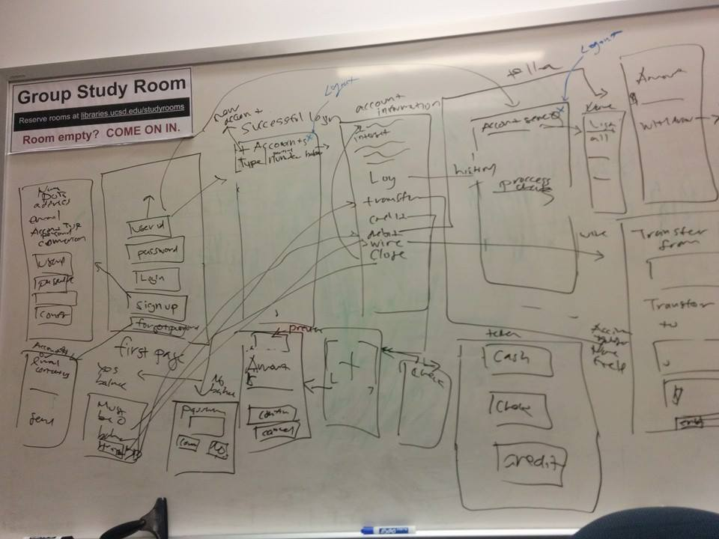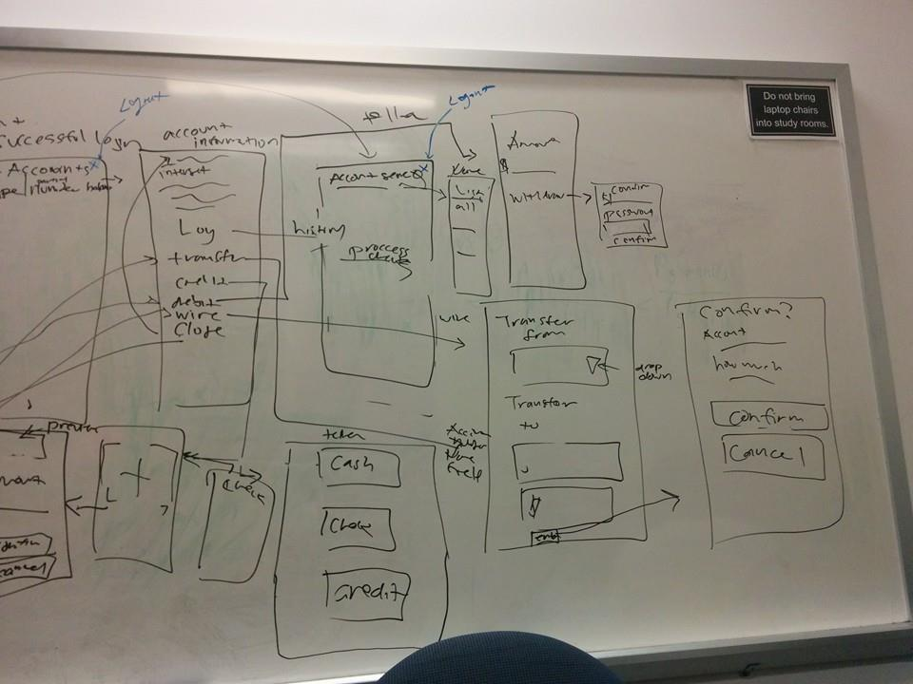

*Comment:*

* + *Describe the system as a set of logical components, connectors using a block diagram or UML.*
  + *e.g. a three-tier architecture consisting of a user interface layer, business layer and a database backend.*
  1. Physical Architecture

*Comment:*

* + *How are the components really connected?*

The physical servers of Parse.com will be hooked up to the internet and accessible to our mobile app. Meanwhile, our mobile app will be communicating to those servers with the mobile device’s connection to the internet via port 80, 443, or other Parse.com available ports.

With sensitive information, our mobile app will be using the HTTPS protocol to assure a secure communication path between our user’s device and our servers.

Our application software will be running on the servers of Parse.com, listening to any authorized request of services from our mobile device application. When a mobile user interacts with our application, the mobile device will send a request to our servers with an authentication encryption. Provided that the user had input the correct credentials, the inquire authorization is confirmed through the designated listening port of our server software. Our server will then process the request and securely respond with the appropriate data or change confirmation to the correct mobile device port.